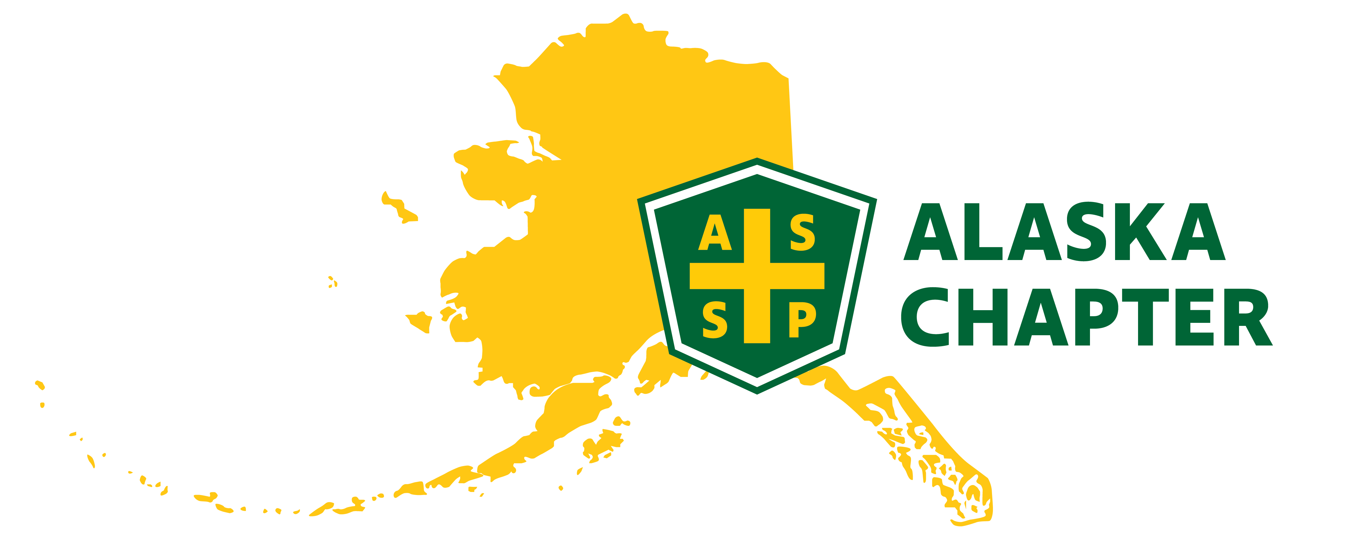
MEETING MINUTES 9/5/2024
time: 09:00 AM – 10:00 AM

Attendance
Mark Strauss
Carrie Parashar
Robert Wood
Michael Stoddard
Clark Vermillion
Paula Pepin

Minutes

- Survey was sent out successfully! Only 12 responses have been received so far.
- Mark created a draft newsletter. Need to send out a link
- At the next chapter meeting, we should mention the survey
- Carrie will create a QR code to link to the survey
- Magnet mail – Mark will show Paula and then she can meet with Clark and Lucas to show them how to use this system.
- Challenge coins submitted to vendor and should arrive on the 9th
- The ROC notebooks came in and will be put in the swag bags. 50 notebooks were ordered.
- Carrie is adding smaller dry bags to swag bags.
- ROC Planning Continued – Contract with Hilton signed and approved by Tracy. This is to include the catering piece.
- Thinking of a chapter outing on Saturdays – Members would be on their own to pay – May look into rental cars/carpool depending on participation interest
- Wildlife Conservation Center (approximately $25/person)
- Portage Glacier Cruise (27 Glaciers Cruise)
- Take the tram in Girdwood
- We should add “Things to Do List” in the ROC swag bags
- Dinner at Orsos is reserved for the 3rd. Capacity is 54
- Annual Operations Plan – Included items that meet requirements.
- Mark added the following goals:
- Host the ROC in Anchorage
- Create AK Chapter specific challenge coins
- Change meetings to hybrid to boost membership involvement
- Include AK ASSP Chapter events/updates on social media platforms liked LinkedIn, Facebook, Instagram
- We should post 23-24 gold member certificate on LinkedIn, Facebook, etc.
- We should think about sharing events such as Safety Connect (You can receive 2.6 CEU credits and price to attend is only $17) and/or safety job opportunities in our newsletters, websites, social platforms, etc.
- Bylaws – Mark hasn’t had a chance to look at these but we should update
- May look at extending elected officials to a two year term
- Mark will bounce this idea off with Tracy at the ROC
- PDC Update – Mark finally heard back from Anne Lindsey. In the past, the PDC has received large sponsors. Is this now a self-supported event?
- Bob will connect with Jonathan Johanssen regarding signature for accounts. Still working on this. Need to figure out how the ROC, coins, Orso dinner will be paid for out which account.
- Carrie and Mike working hard on tours. Here are a few ideas and contacts.
- Northern Solutions
- Chugach Electric – Looking at dates/times
- American Marine
- Enstar – Working with new Safety Officer, Brent
- Amazon – Austin
- Alaska Railroad
- Brewery tours
- SWS – Reached out and waiting for a call back
- AWWU – Hard to get past front desk
- Port? – 10 max capacity – any interest?
- QAP
- Mining Pits
- Granite
- Muni Emergency Operations Center or State EOC

Action Items | Responsible | Target Date
Bylaws – Mark to check with Tracy to see if the President Elect position is required. | Mark Strauss
Review/approve bylaws. | ASSP AK Chapter CEC
Finalize and order challenge coin design. | Mark Strauss | Received 9/9/24
Enter survey into tool. | Paula Pepin / Mark Strauss | Survey emailed to members 8/30/24
Finalize goals for 2024-2025. | ASSP AK Chapter CEC | Completed
Mark will show Paula how to access and use Magnet Mail. Then Paula will show Clark and Lucas | Mark/Paula
Webpage updates – Clark and Lucas will get together to work on this. | Clark Vermillion/Lucas Voshell
Hosting a dinner meal – Mark and Carrie will get together to call different restaurants in the downtown area. | Carrie Parashar/Mark Strauss | Dinner reserved at Orsos on 10/3/24

