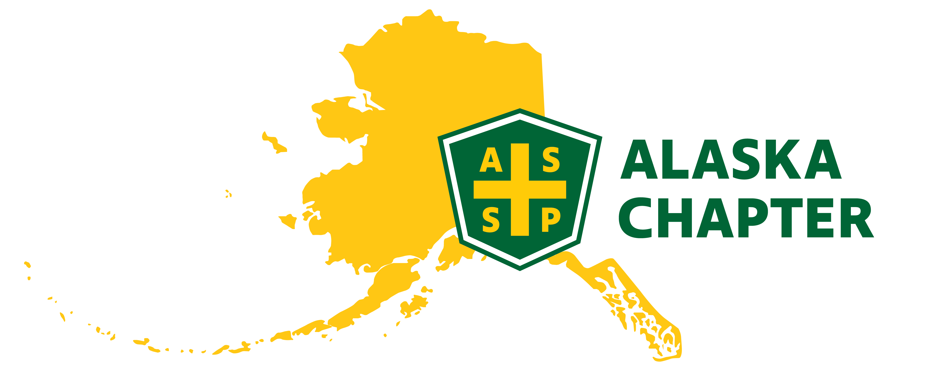
MEETING MINUTES 12/5/2024
time: 09:00 AM – 10:00 AM

Attendance
Mark Strauss
Lucas Voshell
Nick Danger
Paula Pepin

Agenda
- Member survey
- Nomination and Election Committee (NEC)
- January gathering
- Leadership training – Jan 23
- Chapter Operation Management Tool (COMT)
- Social Media
- Webpage updates: set up registration for meetings; post 12/17 meeting
Minutes
- Current membership is 218
- Split the list by 9 CEs
- Mark will send out the list using Google Drive
- Give CEs a few days to highlight and initial if you know a member
- Final survey questions. Should include January meet up on January 21st from 5-8pm
- Hi, I’m ______ and I’m calling you from your local ASSP chapter.
- Do you receive emails from national ASSP?
- Do you receive the local ASSP or AK Chapter ASSP newsletter?
- Did you know the ASSP meetings occur every 3rd Tuesday of the month and that they are hybrid?
- How can we increase participation in the local chapter?
- Mike will lead NEC as past president. Mark will follow-up with Mike. This needs to be completed by the end of the month.
- January Gathering – Clark was researching locations.
- Look at budget
- Providing food and members in charge of purchasing own alcohol
- Paula will call Guidos to check availability, room fees, minimum food charge, etc.
- Lucas will call Midnight Sun Brewing for availability
- Look to schedule for Tuesday, January 21st from 5PM – 8PM / Location TBD
- Can we see activity/clicks on website?
- We should add monthly meetings and social events to Event Espresso – We can track RSVPs
- Next leadership training is January 23rd. Mark can forward the registration link if you have not received it and want to take the course.
- 2024-2025 Alaska COMT Report
- Tracks what we’ve been doing for the year
- We get points for each item we complete during the year and the total points determine what level we reach (typically we reach gold status).
- Mark sent a list of COMT items. Review the list and see if there are things we can start doing for the chapter.
- Social Media – One of our chapter goals is to increase social media presence
- LinkedIn – We do not have an account set-up. Everyone seems to use LinkedIn.
- Lucas and Nick will work on getting an account created for the chapter
- Facebook – Figure out a way to post newsletter from website that will add to Facebook, Instagram, etc.
- Mark will set-up a meeting with Lucas to work on Event Espresso
- Tentative, Monday, 12.9.24 at 1 PM
- Magnet mail was not working this morning. Mark submitted a work ticket and will try again to send out newsletter.

