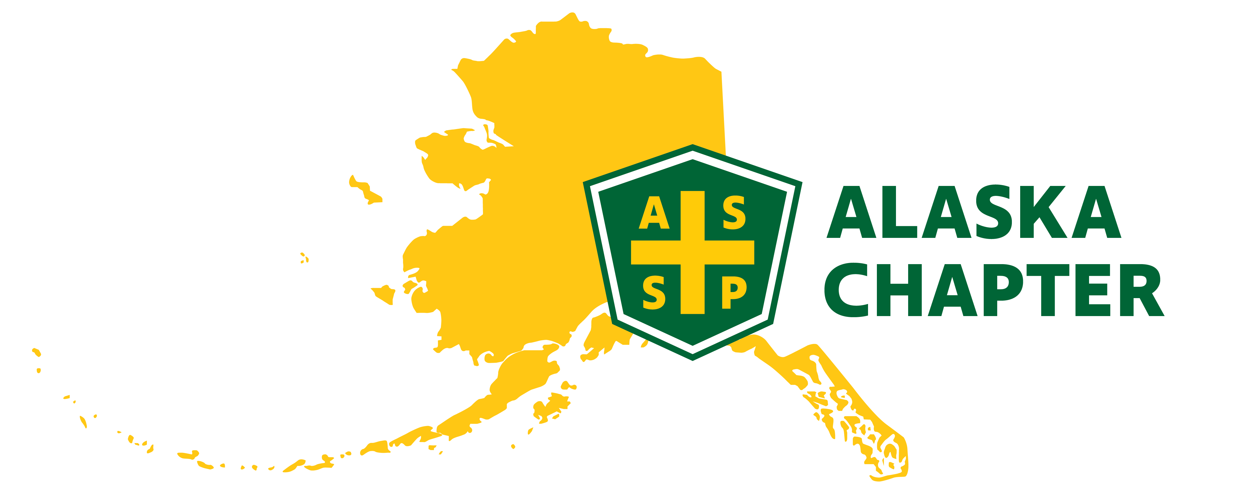
MEETING MINUTES 1/2/2025
time: 09:00 AM – 10:00 AM

Attendance
Mark Strauss
Lucas Voshell
Carrie Parashar
Robert Wood
Michael Stoddard
Paula Pepin

Agenda
- Finalize January Meeting
- Member Survey
- Leadership Training – January 23, 2025
- 2024-2025 Chapter Operation Management Tool (COMT) Report
- Social Media Update

Minutes

- January Meeting – We have two options.
- Tuesday, 1.21.25 Mooses Tooth 11 AM – 1 PM or 1:30 PM – 3:30 PM
- Wednesday, 1.22.25 Guidos 5:00 PM – 8:00 PM
- CEC voted for Wednesday, 1.22.25 at Guidos 5-8 PM
- Mark will update member survey questions to include networking event
- Any interest in BINGO card and a prize? Carrie sent a Bingo draft on 11.7.24. Mark and provide comments and send them back to the group. Bingo card allows members to network and talk to a variety of people.
- Depending on who shows up, we can have 1 or 2 prizes ($50 gift cards to Amazon, Cabelas, Home Depot) Mark can pick up a few.
- Carrie helping with a welcome table to include roster sign-in sheet, pens, box
- Member Survey – Nick and Carrie tried before the holidays. Waiting until next to call once folks are back in the office and have returned to work
- Positive feedback – Members are happy ASSP CEC are reaching out and glad to hear about hybrid meetings! Members are interested in networking.
- Leadership Training – January 23, 2025 – Attend if you can, even if you can only join for a part of the training.
- COMT – Ultimate goal is to reach platinum status. To achieve platinum status, chapter has to more work.
- Reviewed sections during meeting
- Recommend working on keeping regular meetings and add additional networking/social events
- Does the CEC recommend anyone to be on the Advisory committee that reports back to the board? The advisory member cannot be a CEC member.
- Don Maynard? – Carrie reached out to him not too long ago and over capacity
- Sam Cunnard
- Past President – Mike S. – Need a little more information on what this role includes and time commitment
- We can reach out to national ASSP. They offer training often.
- Remind Mark to review ASSP Code of Conduct and CLEAR values at our next meeting.
- Paula will work with Carrie on roster
- Social Media Update
- Once we get LinkedIn up and running, we can use Magnet Mail to link and post all social media sites at the same time (LinkedIn, Facebook, Instagram, Twitter)
- Carrie nominated Mike S. for the Spy award – CEC approved nomination and Carrie will work with Mark to ensure nomination is approved and sent on.

