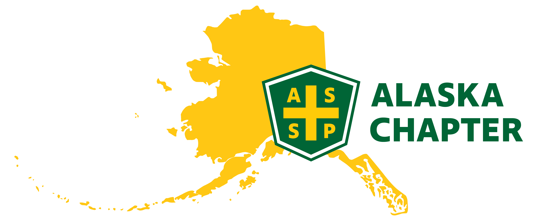
MEETING MINUTES 2/6 /2025
time: 09:00 AM – 10:00 AM

Attendance
Mark Strauss
Lucas Voshell
Carrie Parashar
Brian Gould
Clark Vermillion
Paula Pepin
Nick Danger

Agenda
- Code of Conduct
- Member contact survey - Group
- Social media update - Lucas
- Future social event - Mark
- Leadership training - Mark
- ROC meeting – Carrie

Minutes

- Member Contact Survey
- Lucas has started calling and a majority are receiving national emails but not the local
- Mike had 7 names left to call. Paula will ask Mike to send those names to Clark
- Social Media Update
- Brian will ask the student body to see if anyone is interested in helping with our social media posts
- Clark is regularly checking the ASSP AK email. Only a couple of emails that come through are good
- Future Social Event
- We thought the first social event went well. Around 15 members showed up. Decent turnout.
- We sort of lost networking during COVID, but we can all agree networking is important
- We should set up our next social event. For now, keep it at the same location as possible. This was a central location for all to meet
- Paula will check with Guidos for Thursday, March 13th for 5 PM – 8 PM
- We should reach out to organizations to see of they have any door prizes or swag
- Looking for speakers for April and May
- Paula working on possible tours with Verizon and CEA
- Carrie might have a lead with a behavioral health therapist
- Student affairs created a fun virtual escape room and was well received
- In the future might be fun to do an escape room social event – Downtown has a fun one that can fit 24 people
- Maybe a scavenger hunt that involves learning something new
- ROC Meeting Update – 2/4/25
- The chapter can do CEUs at regular meetings
- It does take some time to get the approval. You must start a month or more in advance to get documents submitted for approval. This might be something we should look at this for next year.
- The ROC coming up will be in Kona, next in Seattle and then Central Valley, CA
- National pushing area directors to develop a process of hand-offs and best practices
- Newly created position – ARVP of Operations
- SPY nominations due March 1st. Carrie is working on the local SPY nomination.
- Advocacy kit can be found in the national site and local/state government
- There is a work group working on getting information for members working on getting certifications
- Are we following up with new members? Mark created an easy note card and sent handwritten notes to new members in the past. This is important to follow-up with all new members and goes a long way
- Chapters should look at speaker strategies and include job opportunities
- At the Regional level, there is a lot of discussion about succession planning
- Any financials that are due at the end of the year. Bob will work on this.
- Regional hired another web guy. They are working through a ticket system
- Feedback provided to regional includes the overwhelming information through the website. It’s very hard to navigate. Regional plans to redo/upgrade the website
- Leadership training
- Part of our COMT report states chapter leadership has taken the leadership training
- If you can, take a few minutes to sign up and take a leadership course for your position
- Let Mark know once you have completed this
- Code of Conduct – This a document that outlines code of conducts and how to deal with members who are not following this
- At the next meeting, Mark can discuss Clear Values and the Code of Professional Conduct
- Governor’s Health and Safety Conference – April 8th and 9th
- Are we considering a booth?
- Carrie will work with Brian to see if the ASSP booth can be next to the UAA student booth. This is not a cheap booth to run but worth checking into.
- Brian will check with student volunteers to help run booth
- Reaching the end of the year – Need to begin thinking about nominations
- Mike is the elected chair for the nominations committee
- Mark will reach out to Mike to get this started
- Is ASSP absorbing cost for UAA students to attend monthly meeting?
- As long as funds are available, we should try to keep this free. Maybe next year we can think about charging members and what this looks like.
- Mark will check with Tracy to see if national is using a different server to send out emails.

