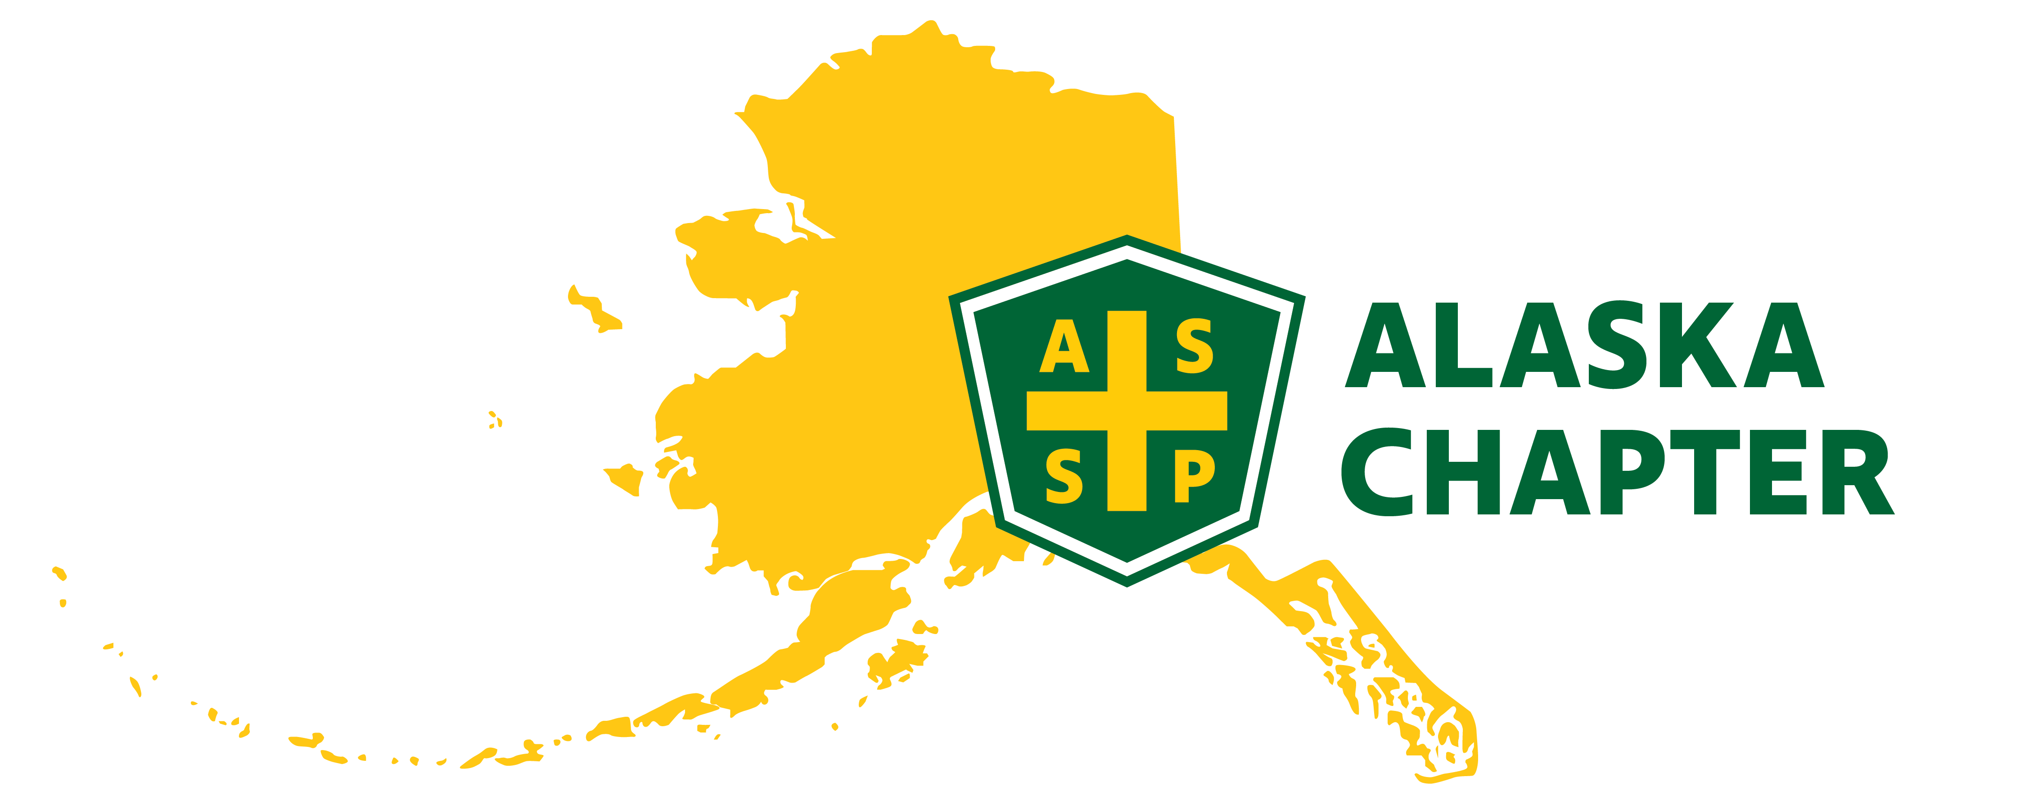
MEETING MINUTES 3/6/2025
time: 09:00 AM – 10:00 AM

Attendance
Mark Strauss
Lucas Voshell
Carrie Parashar
Clark Vermillion
Paula Pepin
Nick Danger

Agenda Items
- Member Survey: https://alaskaassp.survey.fm/monthly-meeting-survey
- Member Survey – Members not receiving emails
- Social media update – Lucas
- Leadership training – Mark
- Nominations and Elections Committee – Mike

Minutes

- For members not receiving emails
- Consider snail mail and sending a quick postcard using Vista Print
- Mark had some notecards printed through Vista Print that were inexpensive. He uses the notecards to write a welcome note to each new member
- We could had some notecards created, pull a member roster and use a generator to divvy up the handwritten notes between committee executives (CE)
- We could also add a sticker with meeting dates
- Do we need to invite students to luncheon meetings? Mark will ask Brian Gould
- Social media
- We haven’t posted to Facebook (FB) in a long time
- We should add our social events and meetings to FB
- How do we increase member likes on FB?
- Typical login/password – update@alaska.assp.org / ASSP@safeawty2022!
- If any CEs want to post on social media sites, best practice is to email this group for review/approval
- Using magnet mail, there is a way to link all social media sites and post materials once. May need to connect with Mark Huelscamp
- LinkedIn – Need to create an account
- Discovered there is a LinkedIn account under the Alaska Chapter of ASSP with 244 members. Created in 2010 by Zeke. Current owners of this account lists Richard Oelkers, AJ and Chris Warner. Carrie will work on this.
- Need to email Zeke to see if has login information
- Leadership Training
- If you haven’t already, there is still time to take leadership training. Training is quick and counts as points on our COMT report
- Nominations and Elections Committee
- Mike is chairing the elections committee. Need to work with Mike and Nick this month for call to nominations
- Member Survey
- Will send this survey link to all participants after a meeting or social event
- We should add to the bottom, send any meeting ideas
- The survey is proof leadership is listening and working on ideas to engage active member participation
- Once a survey is sent out, we should give members 7 days to complete and then close out survey

